IBM ASSIGNMENT 1:

**SCREENSHOT 1:**

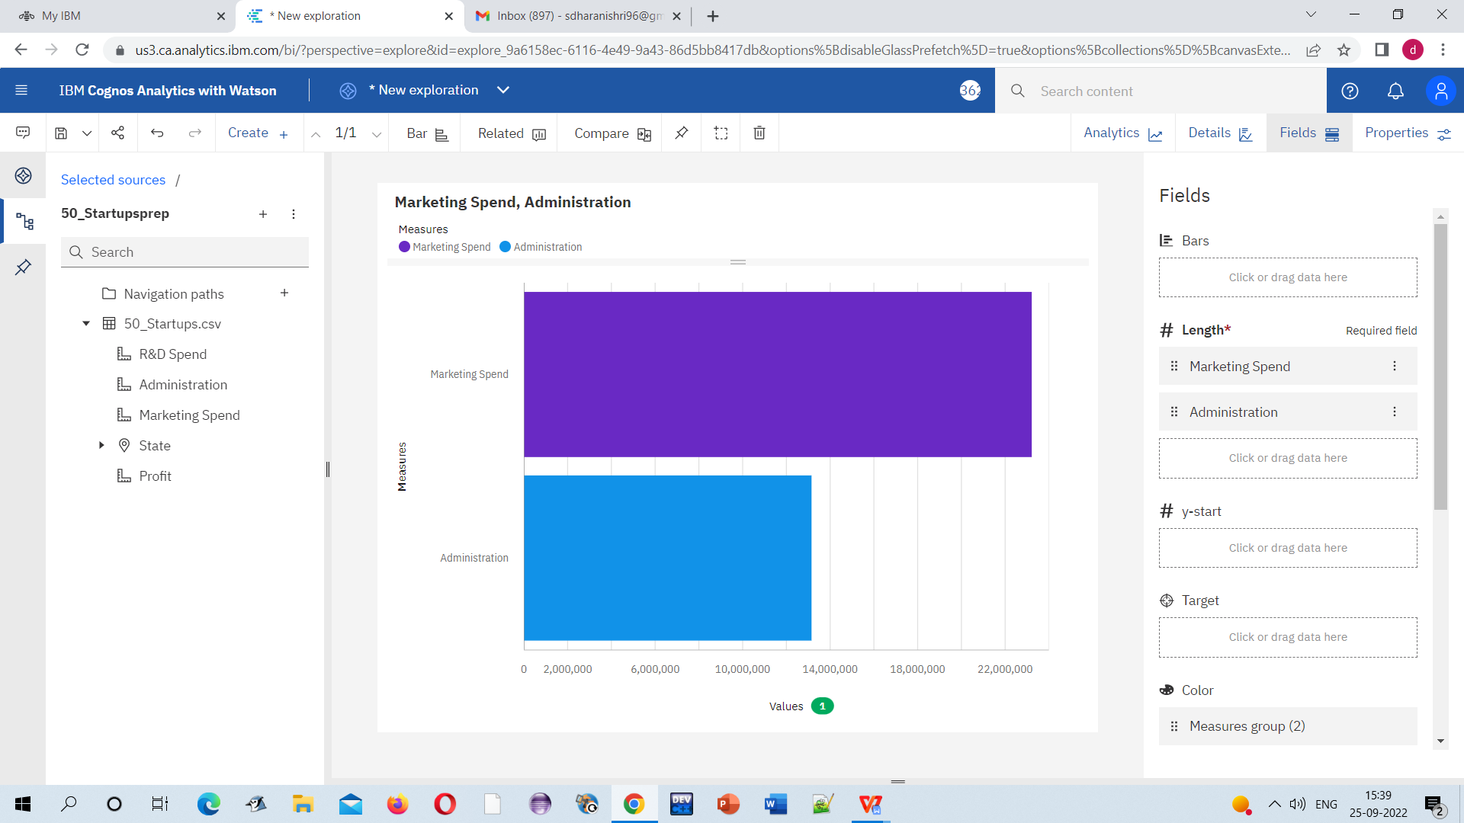

**SCREENSHOT 1 LINK:**

**<https://us3.ca.analytics.ibm.com/bi/?perspective=explore&pathRef=.my_folders%2FMarketing%2BSpend%252C%2BAdministration&subView=model00000183743bef83_00000003>**

**SCREENSHOT 2:**

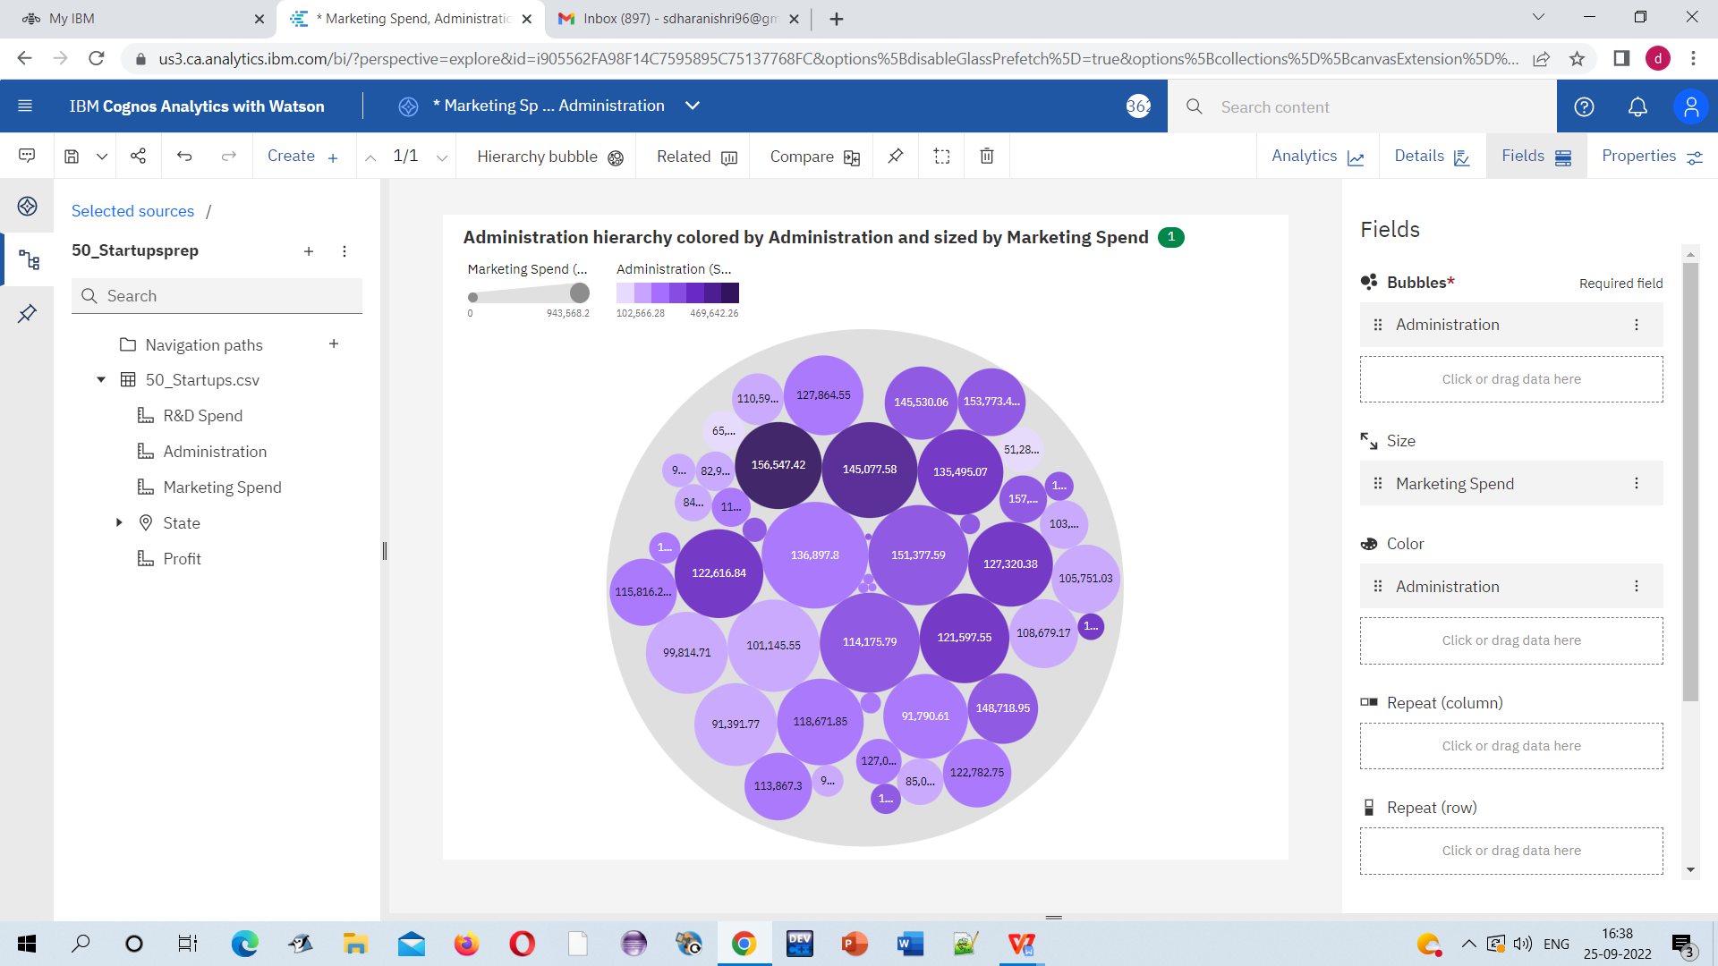

**SCREENSHOT 2 LINK:**

**<https://us3.ca.analytics.ibm.com/bi/?perspective=explore&pathRef=.my_folders%2FAdministration%2Bhierarchy%2Bcolored%2Bby%2BAdministration%2Band%2Bsized%2Bby%2BMarketing%2BSpend&subView=model00000183743bef83_00000003>**

**SCREENSHOT 3:**

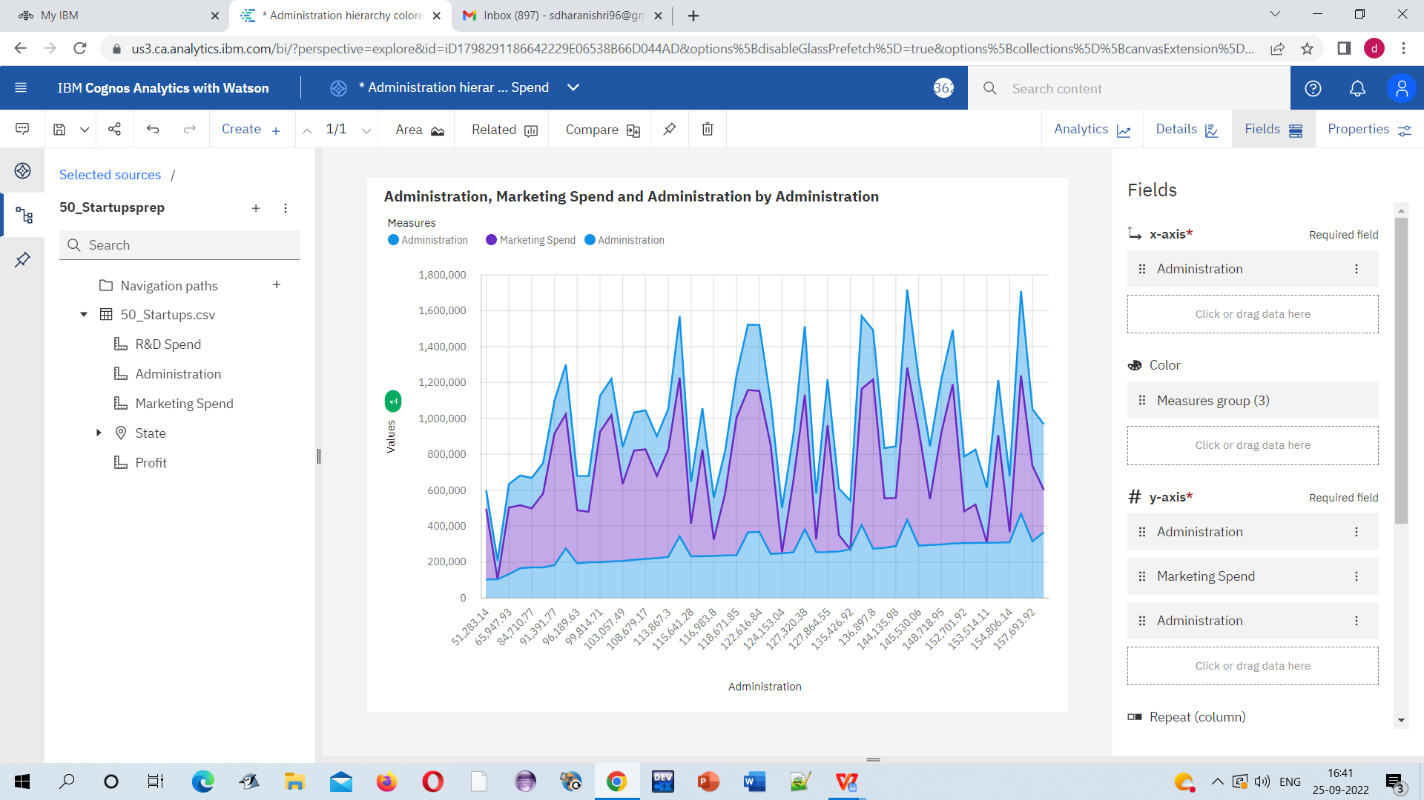

**SCREENSHOT 3 LINK:**

**<https://us3.ca.analytics.ibm.com/bi/?perspective=explore&pathRef=.my_folders%2FAdministration%252C%2BMarketing%2BSpend%2Band%2BAdministration%2Bby%2BAdministration&subView=model00000183743bef83_00000003>**

**SCREENSHOT 4:**

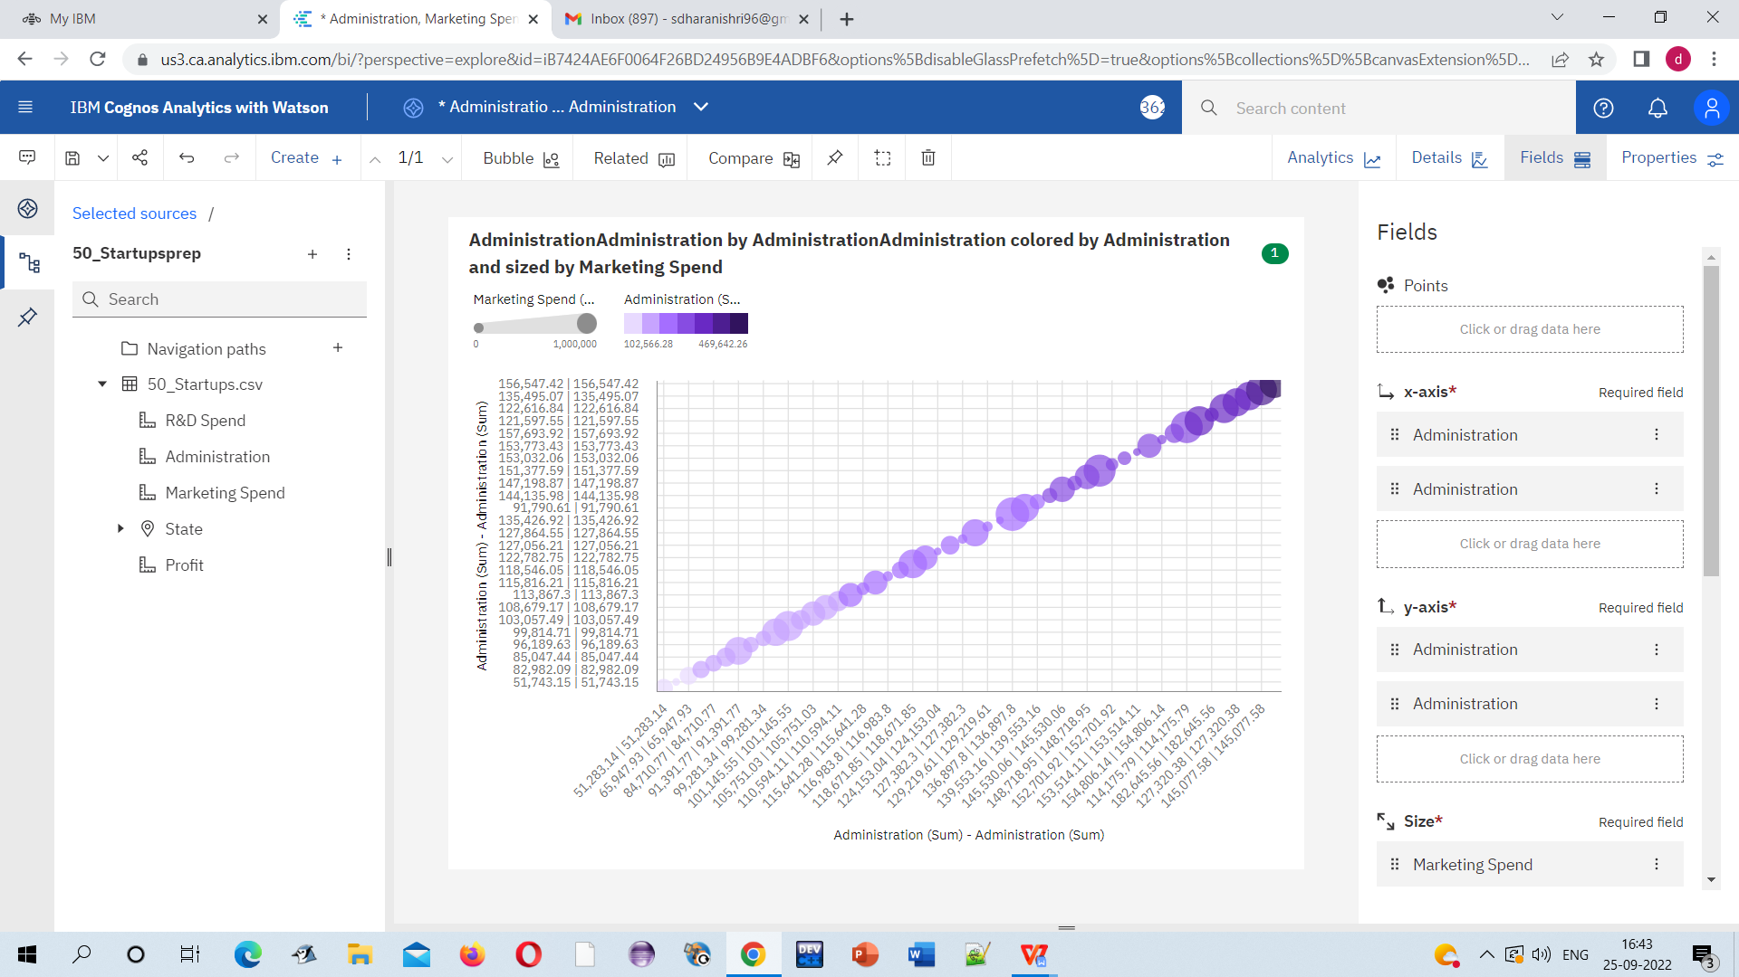

**SCREENSHOT 4 LINK:**

**<https://us3.ca.analytics.ibm.com/bi/?perspective=explore&pathRef=.my_folders%2FAdministrationAdministration%2Bby%2BAdministrationAdministration%2Bcolored%2Bby%2BAdministration%2Band%2Bsized%2Bby%2BMarketing%2BSpend&subView=model00000183743bef83_00000003>**

**SCREENSHOT 5:**

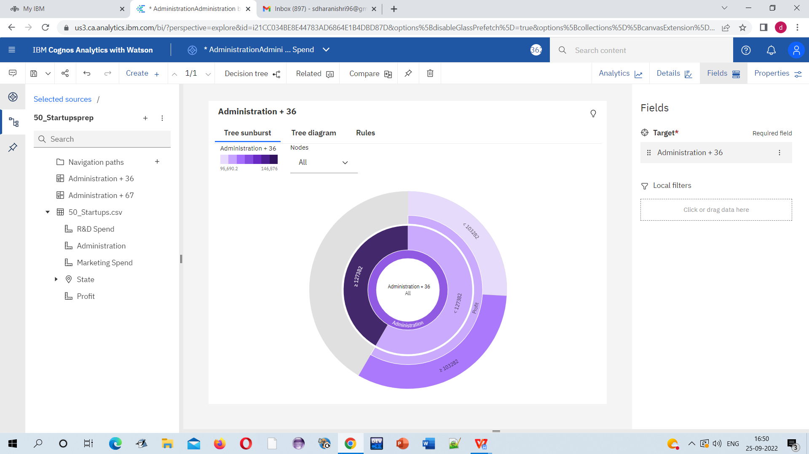

**SCREENSHOT 5 LINK:**

**<https://us3.ca.analytics.ibm.com/bi/?perspective=explore&pathRef=.my_folders%2FAdministration%2B%252B%2B36&subView=model00000183743bef83_00000003>**

**SCREENSHOT 6:**

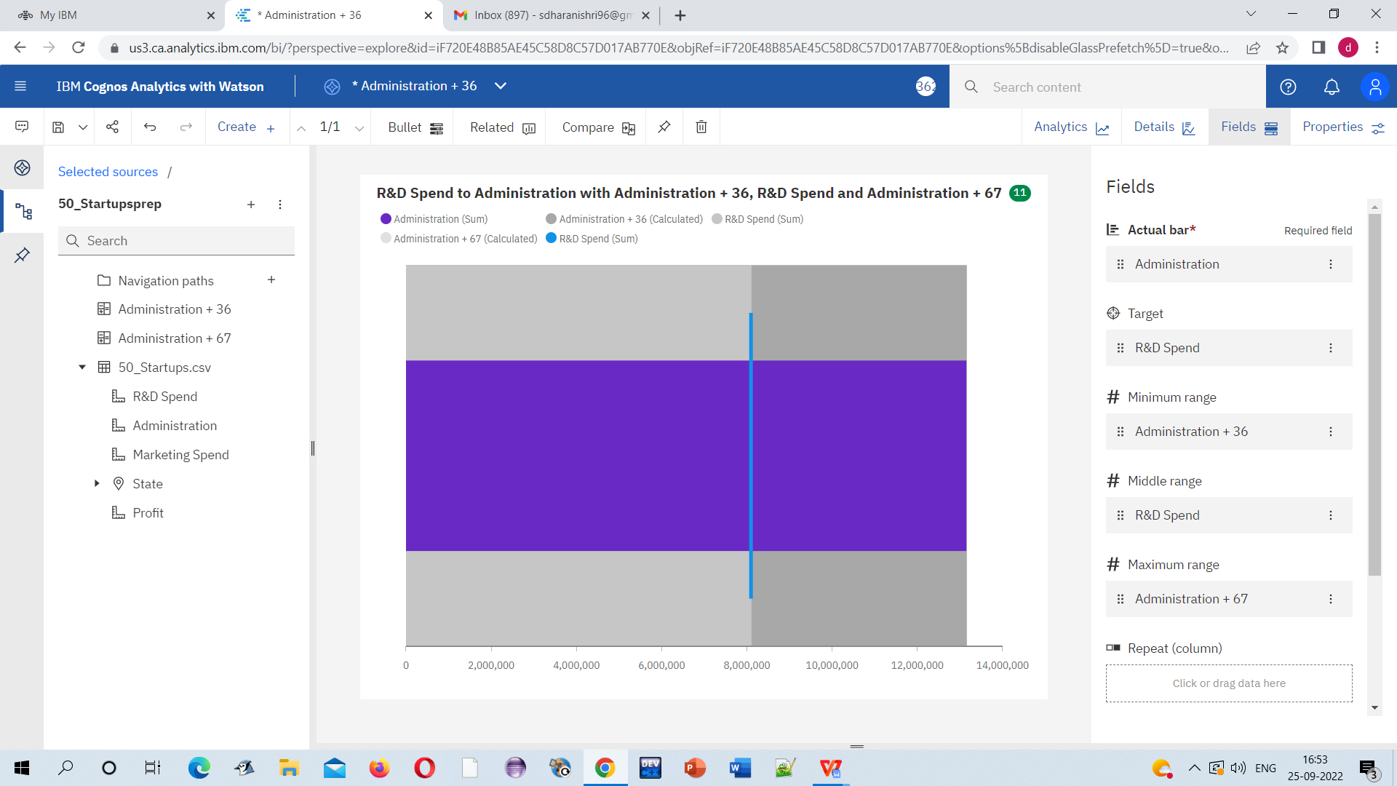

**SCREENSHOT 6 LINK:**

**<https://us3.ca.analytics.ibm.com/bi/?perspective=explore&pathRef=.my_folders%2FR%2526D%2BSpend%2Bto%2BAdministration%2Bwith%2BAdministration%2B%252B%2B36%252C%2BR%2526D%2BSpend%2Band%2BAdministration%2B%252B%2B67&subView=model00000183743bef83_00000003>**

**SCREENSHOT 7:**

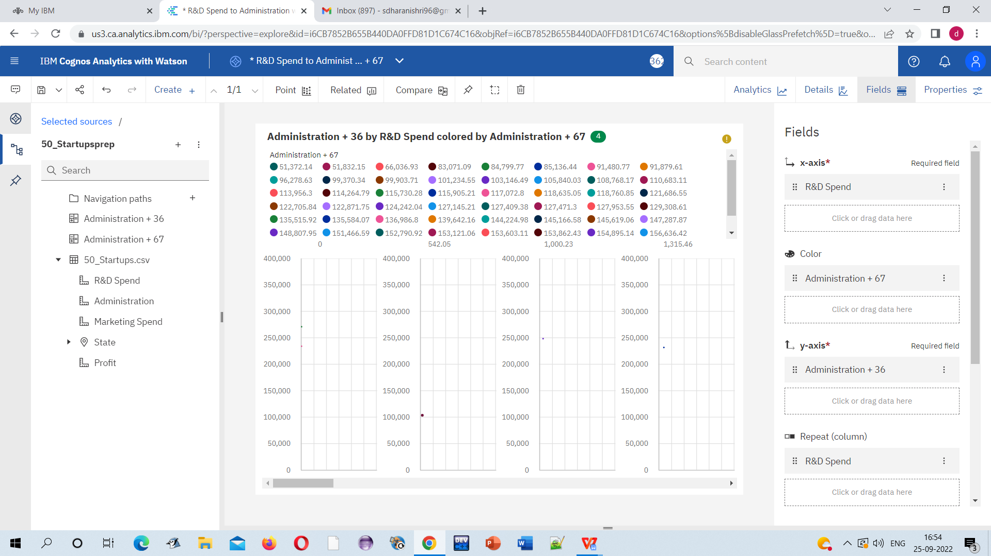

**SCREENSHOT 7 LINK:**

**<https://us3.ca.analytics.ibm.com/bi/?perspective=explore&pathRef=.my_folders%2FAdministration%2B%252B%2B36%2Bby%2BR%2526D%2BSpend%2Bcolored%2Bby%2BAdministration%2B%252B%2B67&subView=model00000183743bef83_00000003>**

**SCREENSHOT 8:**

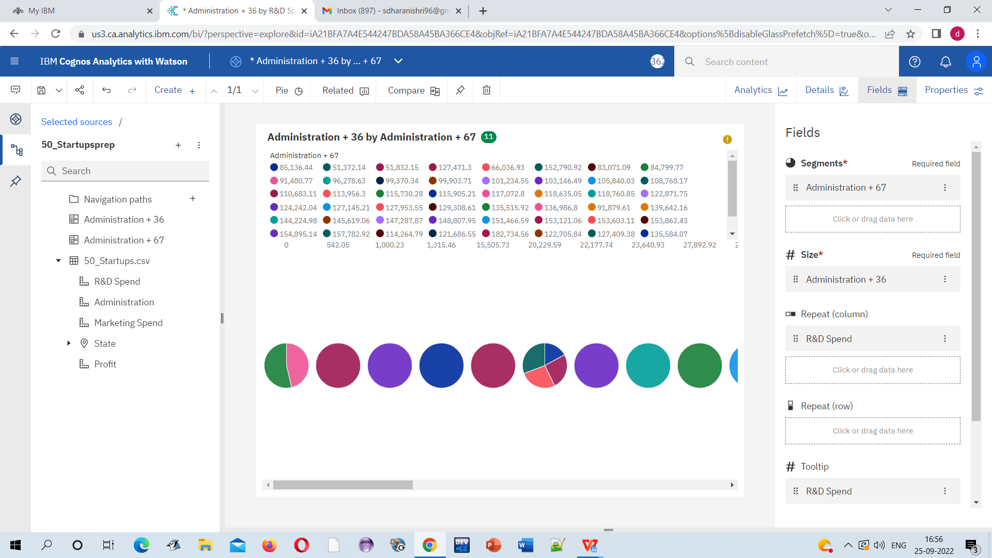

**SCREENSHOT 8 LINK:**

**<https://us3.ca.analytics.ibm.com/bi/?perspective=explore&pathRef=.my_folders%2FAdministration%2B%252B%2B36%2Bby%2BR%2526D%2BSpend%2Bcolored%2Bby%2BAdministration%2B%252B%2B67&subView=model00000183743bef83_00000003>**

**SCREENSHOT 9:**

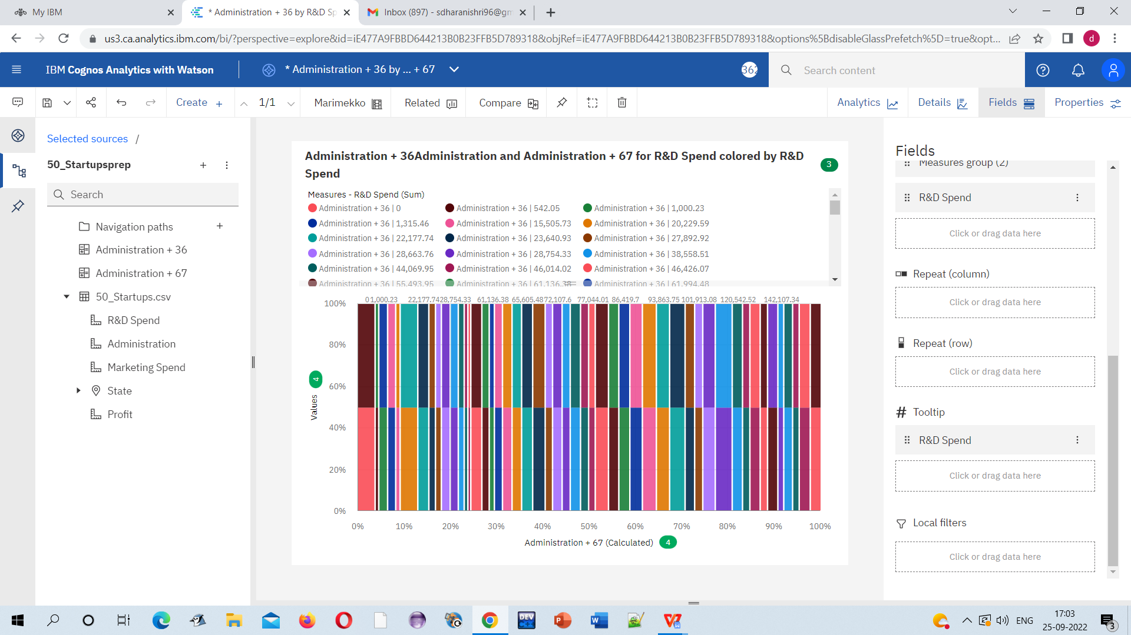

**SCREENSHOT 9 LINK:**

**<https://us3.ca.analytics.ibm.com/bi/?perspective=explore&pathRef=.my_folders%2FAdministration%2B%252B%2B36Administration%2Band%2BAdministration%2B%252B%2B67%2Bfor%2BR%2526D%2BSpend%2Bcolored%2Bby%2BR%2526D%2BSpend&subView=model00000183743bef83_00000003>**

**SCREENSHOT 10:**

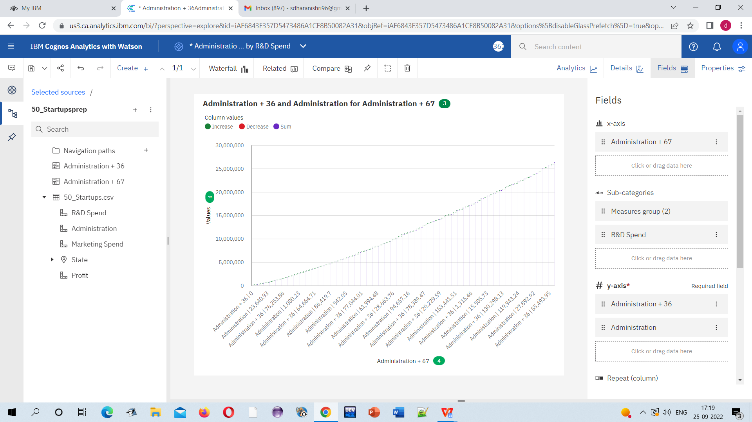

**SCREENSHOT 10 LINK:**

**<https://us3.ca.analytics.ibm.com/bi/?perspective=explore&pathRef=.my_folders%2FAdministration%2B%252B%2B36%2Band%2BAdministration%2Bfor%2BAdministration%2B%252B%2B67&subView=model00000183743bef83_00000003>**

**SCREENSHOT 11:**

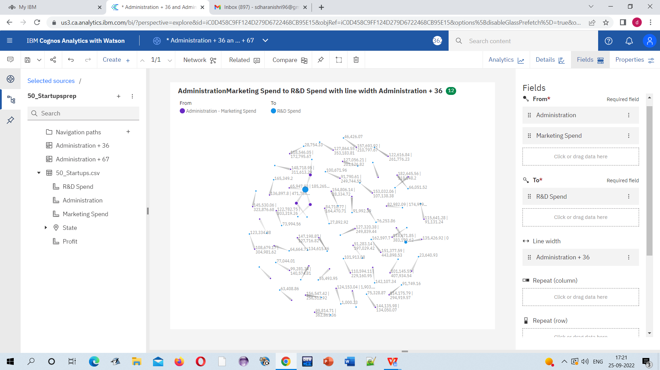

**SCREENSHOT 11 LINK:**

**<https://us3.ca.analytics.ibm.com/bi/?perspective=explore&pathRef=.my_folders%2FAdministrationMarketing%2BSpend%2Bto%2BR%2526D%2BSpend%2Bwith%2Bline%2Bwidth%2BAdministration%2B%252B%2B36&subView=model00000183743bef83_00000003>**

**SCREENSHOT 12:**

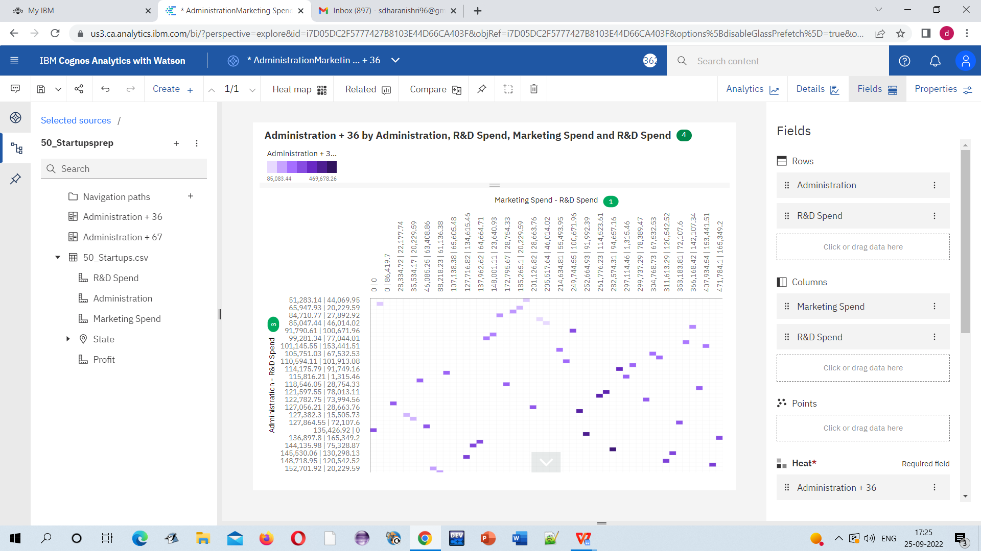

**SCREENSHOT 12 LINK:**

**<https://us3.ca.analytics.ibm.com/bi/?perspective=explore&pathRef=.my_folders%2FAdministration%2B%252B%2B36%2Bby%2BAdministration%252C%2BR%2526D%2BSpend%252C%2BMarketing%2BSpend%2Band%2BR%2526D%2BSpend&subView=model00000183743bef83_00000003>**

**SCREENSHOT 13:**

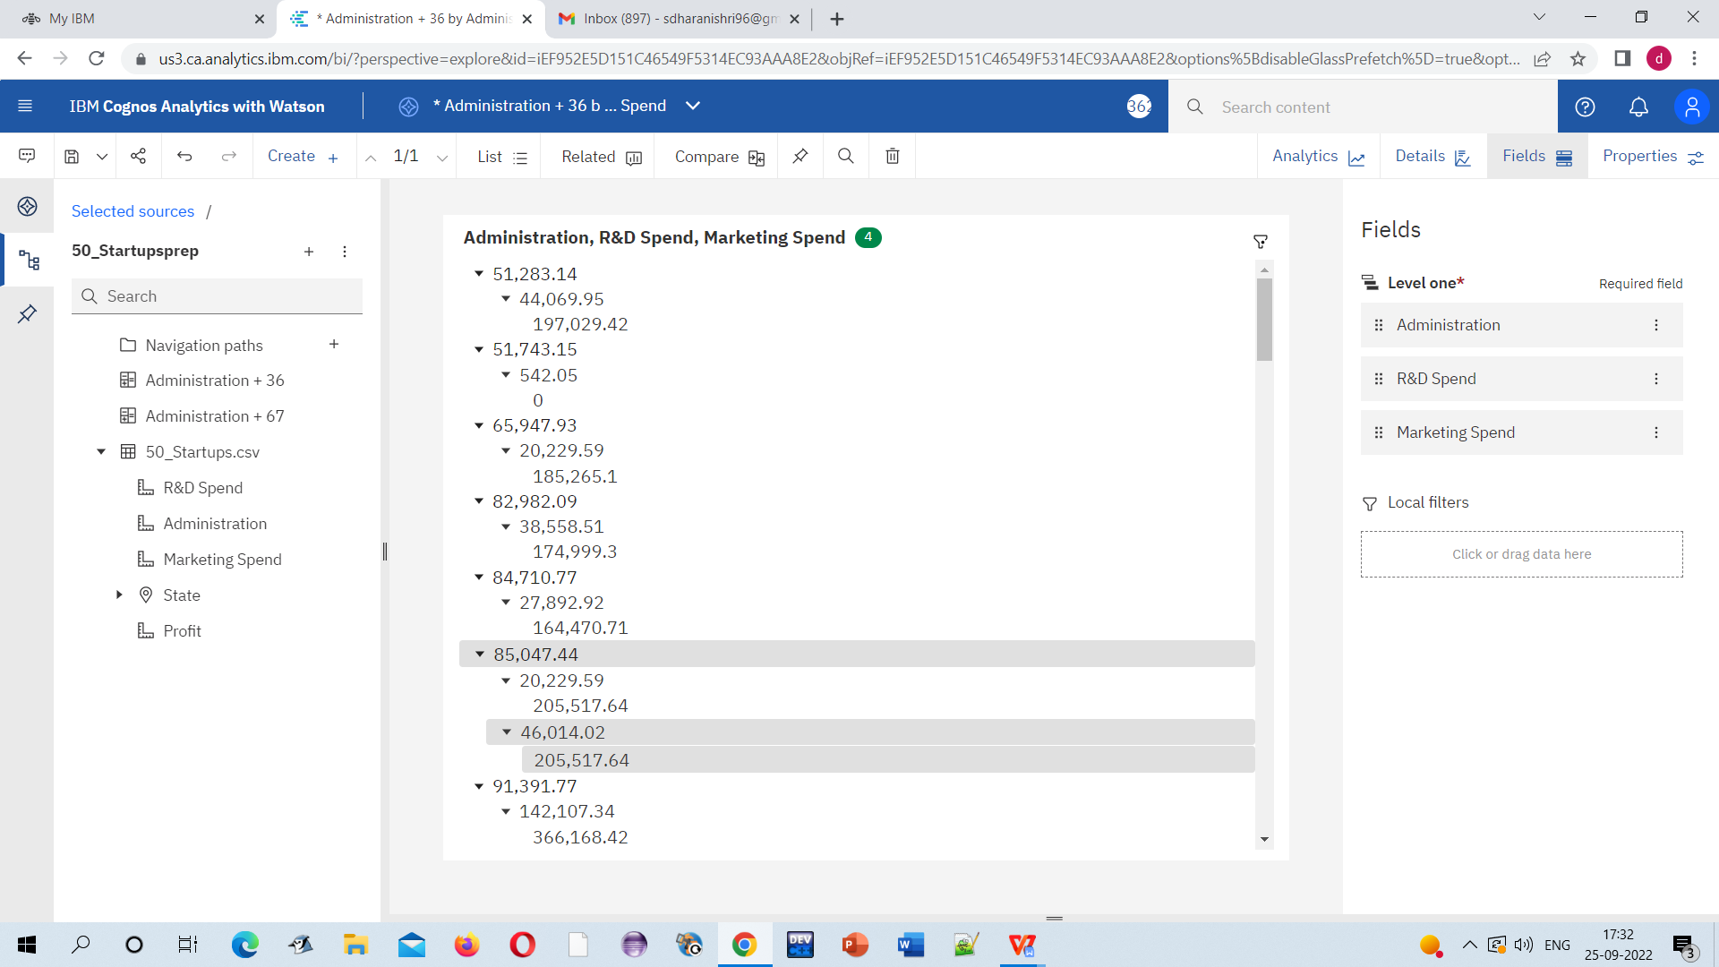

**SCREENSHOT 13 LINK:**

**<https://us3.ca.analytics.ibm.com/bi/?perspective=explore&pathRef=.my_folders%2FAdministration%252C%2BR%2526D%2BSpend%252C%2BMarketing%2BSpend&subView=model00000183743bef83_00000003>**

**SCREENSHOT 14:**

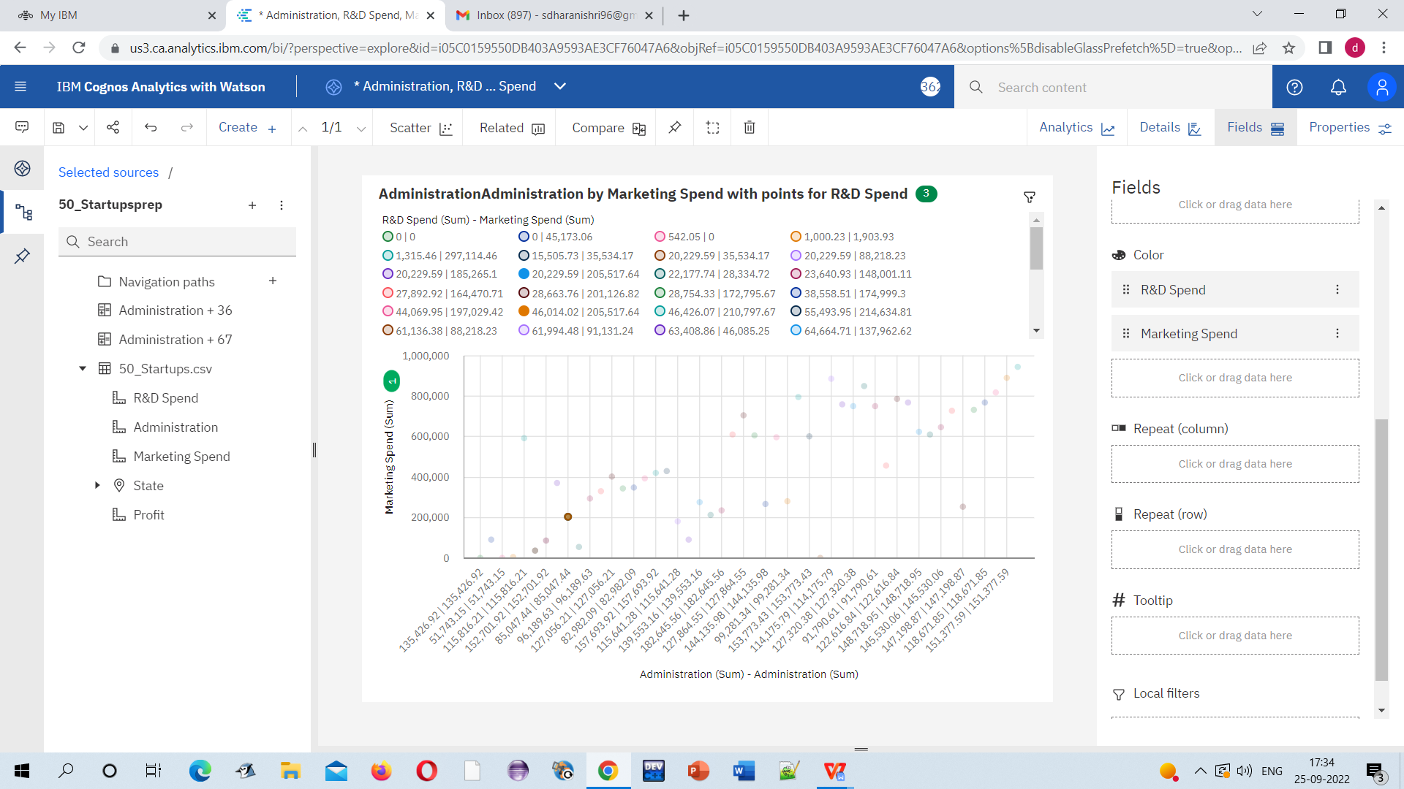

**SCREENSHOT 14 LINK:**

**<https://us3.ca.analytics.ibm.com/bi/?perspective=explore&pathRef=.my_folders%2FAdministrationAdministration%2Bby%2BMarketing%2BSpend%2Bwith%2Bpoints%2Bfor%2BR%2526D%2BSpend&subView=model00000183743bef83_00000003>**

**SCREENSHOT 15:**

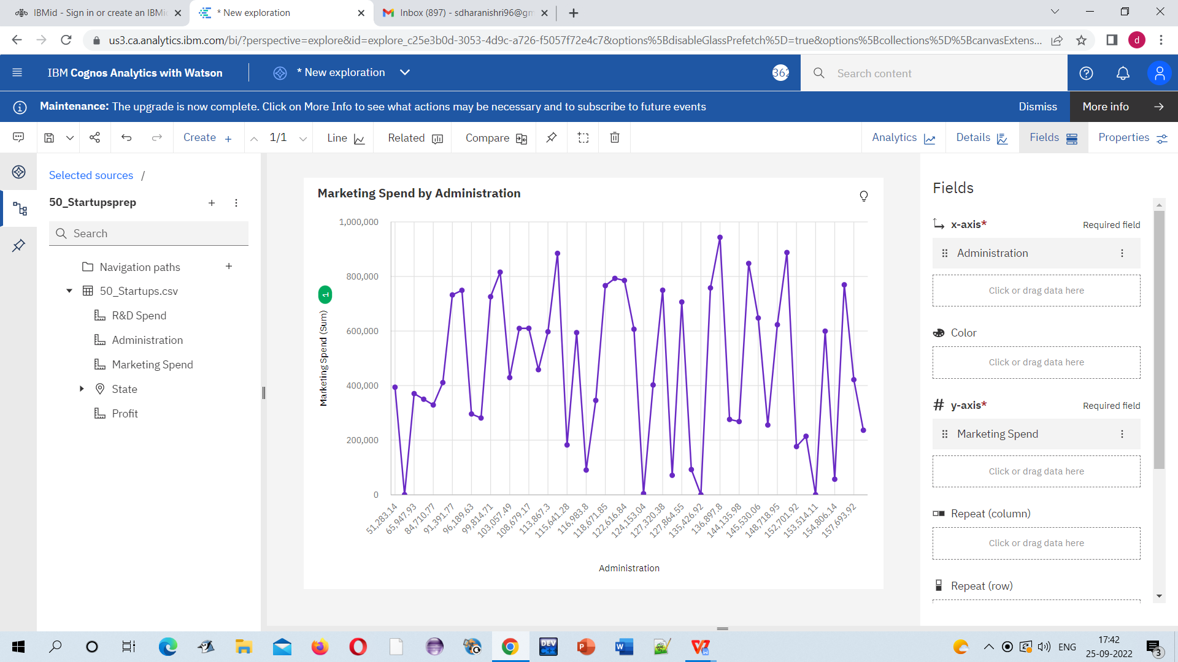

**SCREENSHOT 15 LINK:**

**<https://us3.ca.analytics.ibm.com/bi/?perspective=explore&pathRef=.my_folders%2FMarketing%2BSpend%2Bby%2BAdministration&subView=model00000183749032c3_00000003>**